The Effect of Shortcuts on Judgements of Truthfulness for Online Content

Katherine Hsiao, Sean Stone, Benjamin Storm

University of California, Santa Cruz

Abstract

Since the Internet is a transactive memory partner, people often rely on it for information, yet researchers do not have a thorough understanding of people’s perception of truthfulness with online content. Prior research has indicated that information that has higher fluency tends to have higher judgements of truthfulness. This study will be exploring the effect of shortcuts, as a method to manipulate search fluency, on judgement of truthfulness for online content. Participants were randomly assigned into two conditions: the shortcut condition or the control condition. They were presented with 15 trivia questions one at a time. With each question, they were asked to obtain the answer using a method dependent on their condition and to rate how true they thought the answer was. Time, judgements of truthfulness, and cued-recall data were collected. While there were trending results, there was no significant difference for judgements of truthfulness between the shortcut condition and the control condition.

According to the Pew Research Center, 81% of Americans own a smartphone, which gives them convenient access to the Internet and search engines. Once people start using search engines, they have a tendency to rely on search engines for information (Wang, Wu, Luo & Zhang, 2017). Because of this reliance on the Internet, understanding how people perceive content from the Internet, especially in terms of truthfulness, is important. One of the major current issues is fake news as that spread of misinformation has affected government elections and influenced the public’s perception of politics (Allcott, Hunt, Gentzkow, & Matthew, 2017; Shao et al, 2017). Beyond politics, misinformation can still be harmful as it could affect the education of others. Students utilize the Internet for assistance in their education, and incorrect information would only cause them to be more confused. There are also professions that rely on the Internet to have correct information, such as software engineers trying to understand a computer language library or researchers doing literature review before conducting a study.

When searching for information online with a search engine, it is a common practice to mainly use the first page and to not look any further than that. This is supported by web traffic analytics, revealing that significantly more people interact with the first page of results from a web search than even the second page (Petrescu, 2014). There have not been many studies investigating how the speed of which information is retrieved from the Internet affected its expected accuracy. The exploration of the perception of truthfulness for online content involves knowing how fluency has a relationship to judgements of truthfulness and understanding the Internet as a transactive memory partner.

Judgements of truthfulness is a metacognitive measure of how we rate truthfulness. The ease of which information is perceived, processed, and retrieved -- also defined as fluency -- can impact judgements of truthfulness. The “truth effect” is a psychology phenomenon of information being repeated often to be perceived as truthful. This effect is attributed to having high processing fluency since the more the participant is exposed to the repeated information the faster it is to process that information (Schwartz, 1982). Retrieval and perceptual fluency has also been found to lead to a similar truth-like effect as well. (Ozubko & Fugelsang, 2010; Hansen, Dechêne & Wänke, 2007).

While these studies have been an exploration of truthfulness with one’s own perception, these studies have yet to be extended to search engines and the Internet given people’s relationship to them as a transactive memory partner.

First proposed by Daniel Wegner in 1985, transactive memory is when two or more people are considered to be a single shared system of knowledge and information. Each person in this system is thought of as one storage of memory that is easily accessible by the other members of the system. Because people can remember the location for this information, this system of memory can have more knowledge than an individual. This transactive memory system was originally studied with couples as their level of intimacy leads them to have a shared base of knowledge, i.e knowing when friends’ birthdays are or when family is coming to visit, and to acknowledge that they rely on each to recall their own respective portion of the shared memory.

This type of relationship can also extend to smartphones, and in general to the Internet. Having accessible information on the Internet has led to smartphones and computers to be a transactive memory partner (Sparrow, Liu & Wegner, 2011). In this study, two groups of participants were given trivia statements and then typed the information into the computer. Half of the participants thought that the information was saved, while the other half believed otherwise. Then participants wrote down all the information they could recall. The researchers concluded that because the participants thought they could look up the answers later, they did not commit the information into their memories as those who were unable to save. This seems to be an intuitive reason as people often offload information to no longer recall the content. Instead they remember the location of that information. This reasoning is similar to that of transactive partners; therefore, considering the Internet as part of a transactive memory system is reasonable.

As a transactive partner, the Internet is being treated as an extension of one’s mind and memories. The similarity of search engines and people is further expanded upon in Griffiths, Steyvers & Firl (2017), where they tested if a component of Google search engine could predict human performance on a fluency task. They found that both employed similar solutions to the problem for the most part. Given this similarity of system management, the Internet acts like a part of the mind. This notion was further supported with a study of search fluency of the Intern and metacognition, where the Google search engine acted as a transactive memory partner (Stone & Storm, 2019).

Because the Internet and search engines have been established to have a transactive memory partner with people and people’s judgement of truthfulness is affected by fluency, then the Internet’s fluency should affect people’s judgement of truthfulness. In this paper, the Internet’s fluency was manipulated by utilizing the find shortcut, also known as Control F shortcut, to have participants quickly find the answer while other participants will be unable to use the find shortcut. The goal of this study is to explore the role of search fluency, in terms of shortcuts, on judgements of truthfulness. As prior research supports the information retrieved and perceived quickly have a higher judgement of truthfulness, the hypothesis is that the shortcut condition would have a higher judgement of truthfulness than the control condition.

**Method**

**Participants and design.** A total of 103 undergraduate students from the University of California, Santa Cruz (UCSC) participated for credit in a psychology course (81% female, 18% male, 1% nonbinary; mean age = 20.25). At first, 42 of the participants did this study in person. Then, due to classes being moved online as the university’s response to the coronavirus, the study moved to an online format, where there were an additional 61 participants. We removed a participant from each group for having incomplete data, bringing the total number of participants to 101, with 41 in-person participants and 60 online participants. The online and in-person participants went through the same procedure, with the only exception being that the online group was given an interactive tutorial to ensure they had a thorough understanding of the task since the instruction was previously explained by the researcher in-person.

This was a between-subjects experimental design manipulating two variables: (1) whether the participants were allowed to use the find shortcut, and (2) a counterbalance of the sequence of trivia questions the participants answered. The participant was randomly assigned to either the shortcut condition or the control condition and then they were randomly assigned into counterbalanced conditions. The shortcut condition was where the participant was allowed to use the find shortcut on the keyword provided in the question in order to find the answer. By entering the keyword in the find shortcut in the pdf, the participant would be immediately led to the sentence that contains the answer to the trivia question. In the control condition, the participant was asked to not use the find shortcut and to manually skim through the pdf looking for the keyword. The keyword was provided to ensure that both groups would be led to the same answer.

The order the trivia questions were presented to the participant was counterbalanced. All the participants saw the same trivia questions. There were two different list sequences that the participants could have had. The two lists were generated randomly. This counterbalance was done to ensure that time-on-task effect would be taken into account and to potentially look into primacy and recency effects in the future.

The dependent variables were the cued-recall results and the judgements of truthfulness. There was an answer list to each trivia question, and if the participant had typed in an answer that was on the list, then the participant successfully recalled the answer. Otherwise, the answer would be considered incorrect. Judgements of truthfulness were rated on a scale from 1 to 7, with 1 being definitely false to 7 being definitely true. This was done to follow the conventions established in previous literature when evaluating judgements of truthfulness (Hansen, Dechêne, & Wänke, 2008).

**Material.** We gathered 15 trivia questions based on a variety of obscure topics found on Wikipedia. The reason Wikipedia was used as the source was because it could have questionable information as well as containing a diverse set of topics (Appendix A). The articles were selected based on whether the details of the topic was unknown enough and if there was enough content so that using the find shortcut would lead to a faster search time than those who could not use the shortcut. The trivia question for that article was based on an existing sentence in the article that was then reformatted into a question. The existing sentence had to have a unique word in the sentence that could become a keyword and if the answer could be plausibly false for even the participants in the control condition who would have to read through the article. The answer to the trivia question was no more than a couple of words. The Wikipedia articles were copied and pasted onto blank documents, where all citations were removed. This was to prevent participants from knowing which information Wikipedia had cited as that would affect their ratings on their judgements of truthfulness. All the documents were 2 to 3 pages long and were typed in Arial with size 12 font and 1.5 spacing with an additional space after every paragraph. All the documents were then converted to pdfs, where the page breaks were invisible. These steps were taken to make all the documents look similar. This prevented any confounding variables that were based on how the documents looked or by the length of the document. Piloting ensured that the trivia questions were unfamiliar content and questionably true.

**Procedure.** Participants sat in front of a computer screen that displayed two adjacent windows. One window displayed a computer program and the other displayed a folder with all of the pdfs listed. The online group was told to maximize both windows to simplify the instructions and to alternate between the two windows when needed. The participants were informed that the computer program would present 15 trivia questions one at a time and that the answer could be found in the corresponding pdfs. The shortcut condition participants were explicitly told to use the find shortcut in order to find the answer while the control condition participants were explicitly told not to use the find shortcut.

When the question is presented, there is a keyword in the question that is in all-capitalization. The keyword is how the participants find the answer to the question; the participants in the shortcut condition type the keyword into the find shortcut in the pdf and the participants in the control condition manually look through the pdf for the keyword. Moreover, there was the title of the pdf that was used to find the answer to the question. This is a sample trivia question: “What month did JIMMY WALES launch Wikipedia? Wikipedia.pdf.” After the question was presented, the participants opened the pdf that was stated in the question and to look for the answer according to their condition. Once they found the answer, they were instructed to press ENTER and provide the answer. Participants were instructed to press ENTER only after they had finalized their answer. They were informed that this step was important because the program recorded the time from when the question first appeared to when the participant would press ENTER. This was to check that, on average, the shortcut condition would take less than than the control condition.

After the participants entered their answer, they were asked to rate the answer they had inputted from 1 to 7, representing how true they thought their answer was. A 1 was “definitely false” and a 7 was “definitely true.” The participants were then asked whether they had previously known this information, to which they would answer “Y” for yes or “N” for no. This was to check whether the trivia questions would be obscure enough. Prior knowledge about the trivia question could also have an impact on their judgement of truthfulness for that particular answer, so we recorded that information. If the participant stated that they previously knew the trivia, we excluded that data point from the analysis. The entire process repeated for all 15 questions. On the rare occasion where the participant failed to answer a question or found a different answer than the one we were expecting, we excluded the question from the analysis for that participant. The online study was programmed in such a way that checked the participants input to ensure that the participant had to put down some content before moving on. The online study had this built in for the instances where participants accidentally pressed ENTER too quickly, the program would not move on.

Once the participant finished all of the trivia questions, they played Tetris for 3 minutes as a distraction task. Immediately following, participants were given a cued-recall test that contained the same 15 trivia questions. The participants were asked to answer the question with the answer they had found during the trivia phase, to the best of their ability. There was no time limit for this recall test.

**Results**

First, we checked whether the use of shortcuts did affect the search fluency. As shown in Figure 1, on average, participants in the shortcut condition took 42 seconds (SD = 14.76) on each question while those in the control condition took 87 seconds (SD = 31.23) on each question, meaning that those in the shortcut condition took half the time to find the answer than those in the control condition. This is what we were expecting to get as we purposefully used shortcuts in order to manipulate time. In an independent sample *t*-test, we found a significant difference in time between the shortcut condition and the control condition, t(67.5) = 8.62, p < .001, 95% CI[-52,-32].

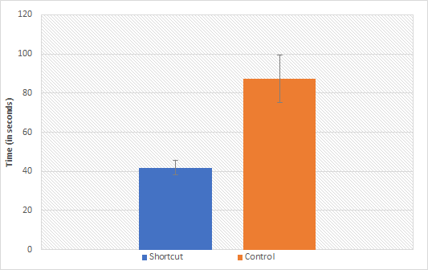

*Figure 1*. The average amount of time in seconds the participant took to answer each trivia question, separated by shortcut and control condition. Error bars represent standard deviation.

When comparing all participants in the shortcut condition and the control condition, the recall test averages for the shortcut condition was slightly higher than the control condition. Participants in the shortcut condition had an average recall of 68% (SE = 6%) while the control condition had an average of 64% (SE = 7%) (Figure 2). The participants in the shortcut condition were better at recalling their answers than the participants in the control condition. Also when comparing the shortcut condition and to control condition in terms of truth value averages, we found that the shortcut condition (5.96 with an SE = 18%) once again had a slightly higher average than the control condition (5.59 with an SE = 20%) (Figure 3). This would indicate that using shortcuts would lead to a higher truth value than those who did not use shortcuts, which supports our hypothesis. However, in a independent samples *t*-test, we found that there was no significance in the recall test results, t(95.2) = 1.35, p = .181, 95% CI [-.02, .11], and that there was no significant difference in the truth values, t(98.9) = 1.56, p = .122, 95% CI [-.09, .72].

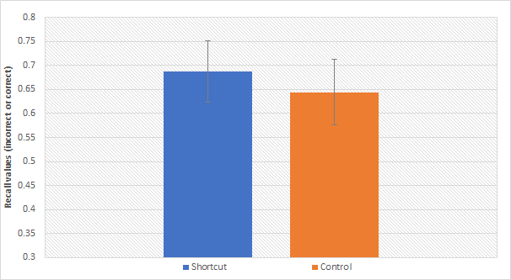

*Figure 2.* Cued-recall test averages between the shortcut and control conditions. Error bars represent one standard error of the mean.

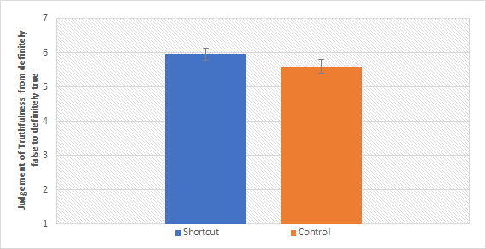

*Figure 3.* Truth averages between the shortcut and control conditions. Error bars represent standard error.

Because there could have been potentially differences between the online and the in-person groups, we analyzed the data between those groups and its interaction with using shortcuts. A 2 (shortcut x control) by 2 (online x in-person) mixed-design ANOVA supports that there was no significant interaction for either recall, F(1) = .510, p = .477, or for truth values, F(1) = .194, p = .660. This indicated that whether the participant was in the online or in-person group did not affect their recall results or the truth values.

However, when analyzing how being online or in-person had an effect on recall and truth values, we finally found a significant difference. As shown in Figure 5, the online group had a higher recall average (online = .67 recall average with an SE = 1%, in-person = .65 with an SE = 3%). This means that the online group in general were able to recall their answers better than the in-person group. Yet interestingly, as shown in Figure 6, the online group had a lower truth average (online = 5.58 with an SE = 13%, in-person = 6.03 with an SE = 15%). This is the only instance where the group with a higher recall average did not also have a higher truth value average. In an independent sample *t*-test for online versus in-person for truth values, we found that participants in-person had a significant higher truth average than those who participated online, t(88.6) = 2.227, p = .028, 95% CI [-.85,-48]. For the independent sample *t*-test for online versus in-person for recall, there was a nonsignificant effect, t(72.3) = .794, p = .43, 95% CI [-.04, .09].

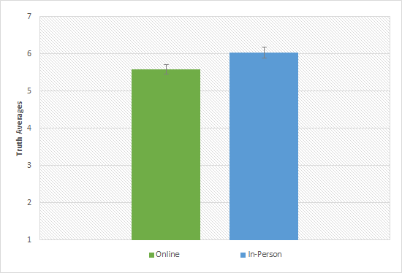

*Figure 4.* Cued-recall averages between the online group and the in-person group. Error bars represent standard error.

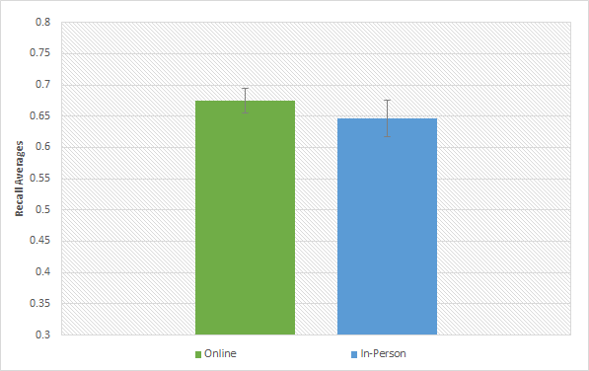

*Figure 5.* Truth value averages between the online group and the in-person group. Error bars represent standard error.

**Discussion**

The results have indicated that there is still much more to dissect about how people make judgements of truthfulness for online content. We had expected the use of shortcuts to play a role as this was our method to manipulate time, or otherwise known as search fluency, and how content that has high fluency would also have higher judgements of truthfulness. While this hypothesis was supported by the trending results, there were not any significant differences between the shortcut condition and the control condition.

It is worth noting that having a portion of the study being conducted online was not intended as there could now be multiple variables to explain the differences between online and in-person groups, regardless of the effort made to keep the procedure similar. There was a time gap between running the in-person group and the online group as there was a duration of a month where research was not being conducted and then research had to be moved online due to a global pandemic. The pandemic itself could have played a role as people could have learned to be more skeptical of information in general, hence why judgements of truthfulness decreased with the online group.

Finally, the next step we will be taking is to conduct a control study. Participants in the control condition are, by design, going to read the content in the pdf. While the answer to the trivia question could still be factually false, the pdf still contained content relevant to the question and therefore these results could be from the control group participants being exposed to more content than the shortcut group. In a future study, we would have the rest of the content be completely irrelevant as to have no impact on the judgement of truthfulness.

As we continue to have the Internet as a transactive partner, we should have a thorough understanding of how that affects our perception of online content as a learning tool. Given the result of the current study, the relationship we have with truthfulness for online content warrants further exploration. Understanding how people perceive online content, especially about how they perceive the truthfulness of that content may be is incredibly important as there is a spread of misinformation and contradicting information.

**References**

Allcott, Hunt, Gentzkow, & Matthew. (2017). Social Media and Fake News in the 2016 Election. Retrieved from https://www.aeaweb.org/articles?id=10.1257/jep.31.2.211

Demographics of Mobile Device Ownership and Adoption in the United States. (n.d.). Retrieved from https://www.pewresearch.org/internet/fact-sheet/mobile/

Griffiths, T. L., Steyvers, M., & Firl, A. (2007). Google and the Mind. *Psychological Science,18*(12), 1069-1076. doi:10.1111/j.1467-9280.2007.02027.x

Hansen, J., Dechêne, A., & Wänke, M. (2008). Discrepant fluency increases subjective truth. *Journal of Experimental Social Psychology*, *44*(3), 687-691.

Ozubko, J. D., & Fugelsang, J. (2011). Remembering makes evidence compelling: Retrieval from memory can give rise to the illusion of truth. *Journal of Experimental Psychology: Learning, Memory, and Cognition,37*(1), 270-276. doi:10.1037/a0021323

Petrescu, P. (2014, October 2). Google Organic Click-Through Rates in 2014. Retrieved from https://moz.com/blog/google-organic-click-through-rates-in-2014

Schwartz, M. (1982). Repetition and Rated Truth Value of Statements. *The American Journal of Psychology,95*(3), 393. doi:10.2307/1422132

Shao, C., Ciampaglia, G. L., Varol, O., Flammini, A., & Menczer, F. (2017). The spread of fake news by social bots. *arXiv preprint arXiv:1707.07592*, *96*, 104.

Sparrow, B., Liu, J., & Wegner, D. M. (2011). Google Effects on Memory: Cognitive Consequences of Having Information at Our Fingertips. *Science,333*(6043), 776-778. doi:10.1126/science.1207745

Stone, S. M., & Storm, B. C. (2019). Search fluency as a misleading measure of memory. *Journal of Experimental Psychology: Learning, Memory, and Cognition*.

Wegner, D. M. (1987). Transactive Memory: A Contemporary Analysis of the Group Mind. *Theories of Group Behavior,*185-208. doi:10.1007/978-1-4612-4634-3_9

Wang, Y., Wu, L., Luo, L., Zhang, Y., & Dong, G. (2017). Short-term Internet search using makes people rely on search engines when facing unknown issues. *PloS one*, *12*(4).

Appendix

List of Topics for the Trivia Questions

1. Ziff Davis
2. Xishuangbanna
3. Borosilicate glass
4. Nova Scotia
5. Optical aberration
6. Vampire Squid
7. Bolsa Familia
8. Toonen v. Australia
9. The Green Slime
10. Cassie Ventura
11. Shamanism
12. Canyoning
13. Traditional Knowledge
14. Katharine Blodgett Gebbie
15. Star-nose Mole

Appendix B

A PDF Example -- Item 9

The Green Slime is a 1968 [science fiction film](https://en.wikipedia.org/wiki/Science_fiction_film) directed by [Kinji Fukasaku](https://en.wikipedia.org/wiki/Kinji_Fukasaku) and produced by Walter Manley and Ivan Reiner. It was written by [William Finger](https://en.wikipedia.org/wiki/Bill_Finger), Tom Rowe and Charles Sinclair from a story by Reiner.

The film was shot in Japan with a Japanese director and film crew, but with the non-Japanese starring cast of Robert Horton, [Richard Jaeckel](https://en.wikipedia.org/wiki/Richard_Jaeckel) and [Luciana Paluzzi](https://en.wikipedia.org/wiki/Luciana_Paluzzi).

After destroying a huge asteroid that was on a rapid collision course with Earth, a group of astronauts discover they have accidentally returned to their space station with an alien slime creature that feeds on radiation and can reproduce rapidly from its own blood.

A group of astronauts set out to blow up the asteroid [Flora](https://en.wikipedia.org/wiki/8_Flora), which is now on a rapid collision course with the Earth. They land on the asteroid, plant explosive charges, and destroy it, barely escaping being destroyed by the explosion's massive shockwave.

Afterwards, they return to the mission's staging area, [space station](https://en.wikipedia.org/wiki/Space_station) Gamma 3, in high Earth orbit. Unfortunately, a scientist from the mission has unwittingly carried back a luminous-green substance on the leg of his spacesuit, which quickly mutates into one-eyed, tentacled monsters with the ability to discharge lethal bolts of electricity.

The Gamma 3 crew fend off the alien creatures with their laser-based weaponry, only to discover the creatures feed off the laser energy which, in turn, allows them to multiply rapidly, sprouting even more one-eyed creatures from their own blood.

As the creatures overrun the station, the crew continues to fight back against overwhelming odds. The proceedings are further complicated by a love triangle consisting of two commanders and a female doctor.

The Green Slime was a co-production between [Metro-Goldwyn-Mayer](https://en.wikipedia.org/wiki/Metro-Goldwyn-Mayer) and [Toei](https://en.wikipedia.org/wiki/Toei_Company). MGM provided the funding and script while Toei provided the film crew and location to shoot the film.The original storyline for The Green Slime originated in Italy, where MGM also had dealings.

Years before The Green Slime went into production, MGM had contracted Italian filmmaker Antonio Margheriti to direct what was originally intended to be a series of four television movies about the adventures of a space station called Gamma One. Margheriti's films in the series consisted of [Wild, Wild Planet](https://en.wikipedia.org/wiki/Wild,_Wild_Planet), [War of the Planets](https://en.wikipedia.org/wiki/War_of_the_Planets_(1966_film)), War Between the Planets and Snow Devils, all created over a period of three months and released in 1965. MGM was impressed with Margheriti's films and released the four films theatrically.

Gamma One producers Manley and Reiner were eager to take advantage of these films and made The Green Slime as an unofficial fifth entry in the film series. The only connection the film had to Margheriti's films is the space station, retitled Gamma Three, which had a similar design as the one in Margheriti's films.Green Slime was shot in Japan with a predominantly Asian film crew and Caucasian actors.

Aside from Horton, Jaeckel and Paluzzi, the rest of the cast consisted of amateur and semi-professional Caucasian actors living in Japan at the time. Yoshikazu Yamasawa was the cinematographer, and the film was edited by Osamu Tanaka. [Toshiaki Tsushima](https://en.wikipedia.org/wiki/Toshiaki_Tsushima) composed the original score. [Charles Fox](https://en.wikipedia.org/wiki/Charles_Fox_(composer)) re-scored much of the film for its release in United States, including the title song

The Green Slime was released in Japan in December 1968. The film premiered in the United States on December 1, 1968, and received a general release on May 21, 1969. The Japanese version of the film runs for 77 minutes in comparison to the 90-minute American version released by MGM, removing the arguments between Rankin and Elliot.

The Japanese version of the film was released on [DVD](https://en.wikipedia.org/wiki/DVD) without English subtitles or dub in 2004. On October 26, 2010, the American version of the film was released on DVD as part of the [Warner Archive Collection](https://en.wikipedia.org/wiki/Warner_Archive_Collection). On October 10. 2017, Warner released a [high-definition](https://en.wikipedia.org/wiki/High-definition_video) [Blu-ray](https://en.wikipedia.org/wiki/Blu-ray) version

Contemporary reviews of the film were mostly negative. [Monthly Film Bulletin](https://en.wikipedia.org/wiki/Monthly_Film_Bulletin) referred to the film as "junior league science fiction" that was "certainly schoolboy stuff". The review commented on the monsters in the film, stating that "the first appearance of the green slime looks promising, but the transformation of the lurid jelly into stock monsters is something of a let-down".

[Variety](https://en.wikipedia.org/wiki/Variety_(magazine)) referred to the film as "a poor man's version of 2001", and described the story, script and special effects as "amateurish". [The New York Times](https://en.wikipedia.org/wiki/The_New_York_Times) stated that the film "opens promisingly, keeps it up for about half an hour but then fades badly [...] the picture falls to pieces when the green menace becomes an army of rubbery-looking goblins".

In a retrospective review, [Stuart Galbraith IV](https://en.wikipedia.org/wiki/Stuart_Galbraith_IV) discussed the film in his book Japanese Science Fiction, Fantasy and Horror Films, finding that Fukasaku's direction was "flat and uninteresting" and that the special effects by ex-Toho employees Yukio Manoda and Akira Watanabe were worse than their previous work with [Eiji Tsuburaya](https://en.wikipedia.org/wiki/Eiji_Tsuburaya), noting that the "miniatures are badly lit and lacking in detail".

Galbraith commented that the film was "ultimately undone by some of the most laughably ridiculous monsters in screen history" and that "the film isn't bad until the critters show up". In [Phil Hardy](https://en.wikipedia.org/wiki/Phil_Hardy_(journalist))'s book Science Fiction (1984), the film was described as "not a very convincing entry in the vegetable monster movie subgenre".

Appendix C

Screenshot of the Program



This is the format of every trivia question. Each prompt appeared once the previous one was answered and the participant pressed ENTER. Once the participant answered each prompt of the trivia question, the next trivia question would be presented until all 15 trivia questions were completed.